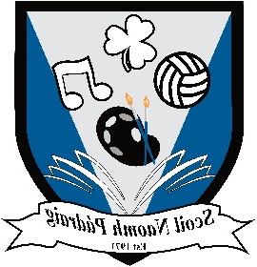 St Patrick’s N.S.
Ballyfarnon,
Boyle,
Co. Roscommon.

Roll No: 13978B Reg. Charity No: 20133375

ANNUAL ADMISSION NOTICE
in respect of admissions to the 2026/2027 school year

Admission Policy and Application Form
A copy of the school’s Admission Policy and the Application Form for Admission for the 2026/27 school year is available as follows:
To download at: www.ballyfarnonns.com ( if you cannot access the website, please refer to the alternative means below):
Or request by: emailing ballyfarnonns@gmail.com
or
calling to the school to collect an admissions pack
or
writing to: The Principal
St Patrick’s N.S.
Ballyfarnon,
Boyle,
Co. Roscommon
F52 CX60

PART 1 - Admissions to the 2026/27 school year

Application and Decision Dates for admission to school year 2026/2027

The following are the dates applicable for admission to Junior Infants
The school will commence accepting applications for admission on | 08/12/2025
The school shall cease accepting applications for admission on | 28/02/2026
The date by which applicants will be notified of the decision on their application is | 28/03/2026
The period within which applicants must confirm acceptance of an offer of admission is | 29/04/2026

*Failure to accept an offer within the prescribed period above may result in the offer being withdrawn
Note: the school will consider and issue decisions on late applications in accordance with the school’s admission policy.

Number of places being made available in 2026/2027

The number of places being made available in junior infants is | 13

