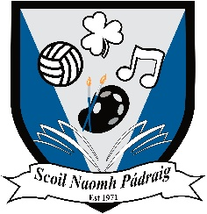

School Uniform
Boys | Girls
- Navy jumper (no crest)  - Light blue polo/ shirt  - Grey trousers  - Dark shoes | - Navy jumper (no crest)  - Light blue polo/ shirt  - Grey pinafore/ skirt/ trousers  - Dark shoes

School Tracksuit (Optional)
If you would like to purchase a school tracksuit, you can do so from the school directly either via email or phone. Choose the individual sizes for a top and a bottoms. Prices and sizes are outlined below per full tracksuit. Please note that these tracksuits are worn on PE days and on school trips.

Sizes | Price
4-5 years | €35
5-6 years | €35
7-8 years | €35
9-10 years | €35
10-11 years | €35
Adolescent 30-31 | €40
Adolescent 31-32 | €40

